**Presence of macroalgal (*Sargassum* spp.) propagules reduces feeding on algal turfs by coral reef fishes**

Andrew S. Hoey1*, Zoe Loffler1*, Alexia Graba-Landry1, Samuel A. Matthews, Morgan S. Pratchett1

1 ARC Centre of Excellence for Coral Reef Studies, James Cook University, Townsville, QLD 4811, Australia

* ASH and ZL contributed equally to this study

[Andrew.hoey1@jcu.edu.au](mailto:Andrew.hoey1@jcu.edu.au); +61 7 4781 5979

Running page head: Macroalgal propagules suppress grazing rates

## Highlights

* Presence of macroalgal propagules reduced grazing on algal turfs on coral reefs
* Grazing of algal turfs dominated by small-bodiedblennies, rather than larger herbivorous fishes
* Reduced grazing on propagules may lead to macroalgal expansion on coral reefs

## Author Contributions: ASH, ZL and AGL conceived and designed the experiments. ZL and AGL performed the experiments and ZL and SAM analysed the data. ASH and ZL wrote the manuscript, all authors edited the manuscript.

**Key words:** Grazing lawn, macroalgae, herbivory, coral reef, incidental grazing, blenny, *Ecsenius,* epilithic algal matrix

**Abstract**

Incidental grazing of seedlings of woody plants or macroalgal propagules by herbivores is often assumed to be a key process preventing shifts from assemblages of small, highly productive herbaceous plants, to larger, less productive woody vegetation. On coral reefs, the proliferation of macroalgal biomass following reductions in herbivory has led to a widely-held view that grazing fishes control macroalgal assemblages through the removal of macroalgal propagules within turf algal assemblages. However, it has never been explicitly tested whether fishes target, avoid, or incidentally graze on these early life stages of macroalgae. Here, we investigate how the presence of propagules of a common coral reef macroalga (*Sargassum swartzii*) within turf algal assemblages influenced feeding by grazing fishes. We established algal turf assemblages on small (11 × 11 cm) terracotta tiles, and seeded half of the tiles with propagules of *S. swartzii* (mean density = 10.1 propagules/cm2). Paired tiles (with and without propagules) were then exposed to local herbivorous fish assemblages or placed within exclusion cages within two habitats (reef crest and reef flat) on Lizard Island, northern Great Barrier Reef, for six days. Although survival of *Sargassum* propagules was 39% lower on tiles exposed to local fish assemblages than on caged tiles, video observations revealed that the presence of *Sargassum* propagules reduced grazing rates on algal turfs by 36%. Indeed, 18 of the 21 fish species recorded took fewer bites on algal turfs containing propagules than those without, with small-bodied fishes (f. Blenniidae: *Ecsenius* spp) accounting for 85% of all bites recorded. These results indicate that while grazing is an important source of mortality for *Sargassum* propagules, grazing fishes reduce feeding in areas with propagules and may lead to a mosaic of grazing intensity across reef habitats, and potential lead to the gradual expansion of macroalgal biomass on coral reefs.

## Introduction

Herbivory is a key process influencing the biomass, productivity, and composition of primary producer communities across a range of terrestrial and aquatic ecosystems (Lubchenco and Gaines, 1981; Hay et al., 1983; McNaughton, 1984; Gill and Beardall, 2001). While the nature of herbivory and its importance relative to other processes varies among ecosystems, areas of high grazing intensity are typically characterised by a low standing biomass of highly productive herbaceous vegetation; a ‘grazing lawn’ (*sensu* Bell 1971; McNaughton 1984). Marked reductions in grazing intensity can, however, cause shifts to communities characterised by a high standing biomass of larger, less productive and less palatable woody vegetation (e.g., Anderies et al., 2002; Folke et al., 2004; Hughes et al. 2007; Hempson et al., 2015). While the prevention of such shifts is often related to the grazing of woody seedlings or macroalgal propagules (McNaughton, 1984; Olff et al., 1999; Uytvanck et al., 2008), the extent to which seedlings are incidentally consumed or targeted is likely to vary among grazing species and ecosystems (Olff et al., 1999; Smit et al., 2006).

Within coral reef ecosystems, shifts between short turf algal assemblages and stands of tall, canopy-forming (typically brown) macroalgae have been linked to changes in rates of herbivory (Done, 1992; Hughes, 1994). On reefs with functionally intact herbivore assemblages, over 90% of daily algal production is consumed by grazing fishes and invertebrates (Hatcher and Larkum, 1983; Polunin and Klumpp, 1992), with algal assemblages dominated by short, highly productive algal turfs (*sensu* a grazing lawn). However, reductions in grazing intensity due to overfishing or experimental exclusion can release algal communities from top-down control and ultimately lead to a shift to tall, canopy-forming macroalgae (e.g., Lewis 1986; Hughes 1994; Hughes et al. 2007; Rasher et al. 2013). Such shifts to macroalgal-dominance following reductions in grazing, coupled with the inability of most grazing fishes to consume large fleshy macroalgae (Bellwood et al., 2006; Hoey and Bellwood, 2009), has led to the assumption that incidental grazing of macroalgal propagules is important in preventing the establishment of macroalgae on coral reefs.

Despite the potential importance of incidental grazing of macroalgal propagules in shaping algal communities on coral reefs, the vast majority of research on the susceptibility of macroalgaeto herbivory has focused on the consumption of larger and later life stages (i.e., adult) macroalgae (e.g., McCook 1997; Hoey and Bellwood 2009; Vergés et al. 2011; Loffler et al. 2015). Few studies have investigated the susceptibility of propagules to grazers (but see Diaz-Pulido and McCook 2003; Loffler and Hoey 2019). Rather, the mortality of macroalgal propagules has largely been inferred from changes in algal communities following reductions in, or exclusion of, herbivorous fishes. It is currently unknown if grazing fishes can detect the presence of macroalgae propagules within turf algal assemblages, and if so, whether the presence of propagules alters their feeding behaviour.This study, therefore, aimed to investigate if the presence of *Sargassum* propagules (a common macroalga on degraded coral reefs (Hughes, 1994; Rasher et al., 2013; Graham et al., 2015)) within the turf algal assemblages affects the feeding behaviour of grazing fishes.

## Materials and Methods

### Study Location

This study was conducted at Lizard Island in the northern Great Barrier Reef (GBR), Australia (1440’S, 14528’E; Fig. S1). Lizard Island is a high continental island approximately 40 km from the Queensland coast, with adjacent islands creating a large lagoonal area, and fringing reefs surrounding each island. The reefs surrounding Lizard Island had low coral cover at the time of the study due to the two cyclones and coral bleaching events that occurred from 2014-2017 (Madin et al., 2018; Hughes et al. 2019).

To determine if the presence of *Sargassum* propagules affected grazing rates on algal turf assemblages, paired experimental tiles with established algal turf assemblages (one containing *Sargassum* propagules, the other without) were exposed to local herbivorous fish assemblages for six days. This research was conducted at each of two reef crest (1.5-3.5m depth) and reef flat sites (0.5-2.5m depth) in early December 2017 (Fig. S1). These two habitats were chosen due to differences in their algal and herbivorous fish assemblages. The reef flat habitat around Lizard Island is characterised by a higher abundance of macroalgae, predominantly *Sargassum cristaefolium*, *Turbinaria ornata* and *Halimeda* spp., and lower fish biomass than the reef crest habitats (Hoey and Bellwood 2009, 2010a). Conversely, the reef crest sites generally have a higher cover of turf algae and greater fish biomass than the reef flat.

### Cultivation of algal assemblages

Algal turf assemblages were cultivated on 76 small terracotta tiles (110 × 110 × 10 mm), and half the tiles were seeded with *Sargassum* propagules. Thirty-eight tiles were placed on the bottom of each of two 1000 L outdoor aquaria (76 tiles in total) with supplemental aeration and flow through unfiltered seawater to seed tiles with a bacterial film and algal turf assemblage. The two aquaria were positioned side by side and received fresh seawater from the same source. Each tile was marked with a unique number on one edge using a permanent marker. After ~2 days, tiles within one aquarium were seeded with propagules of *Sargassum swartzii*.

To obtain propagules, fifty adult, reproductive *S. swartzii* thalli were collected by hand from the inshore reefs of the Turtle Group (1443’S, 14512’E), approximately 28 km west of Lizard Island and 11 km from the mainland. Although there are several *Sargassum* species present at Lizard Island (including *S. swartzii*:Hoey and Bellwood 2010a, b), the higher density in the Turtle Group ensured that sufficient reproductive thalli of the same species could be obtained. *Sargassum* thalli were transported back to Lizard Island within 3 h of collection in 80 L plastic aquaria filled with seawater. Approximately 5 h after collection the *Sargassum* thalli were placed in an 80 L aquarium filled with cold (9C) seawater for 10 minutes to stimulate propagule release (following Carl et al. 2014). *Sargassum* thalli were then transferred to one of the 1000 L aquaria containing settlement tiles at ambient seawater temperature (26 C). The water flow to both aquaria was turned off and both aquaria were supplied with supplemental aeration. The *Sargassum* thalli were agitated by hand twice per day to further encourage release of the propagules. After three days the adult *Sargassum* was removed and flow-through seawater was resumed for both aquaria.

The tiles were cultured in these aquaria with flow-through seawater and supplemental aeration for a further ten days, to allow the *Sargassum* propagules time to firmly attach to the tiles (Fletcher and Callow, 1992). At settlement, propagules were approximately 0.2 mm in height, and only visible under a dissecting microscope. All 76 tiles were then translocated to a sheltered back reef site (depth 1-3 m) on the leeward side of Lizard Island (Fig. S1) and placed within mesh cages (320 × 150 × 40 mm, 5mm plastic mesh; two tiles per cage) for 21 days to allow turf algal assemblages to establish in the absence of herbivory. After 21 days, the tiles were collected, transported back to the research station in aquaria filled with seawater, and placed into large aquaria with flow-through seawater, and the density of *Sargassum* propagules on each tile quantified.

The density of propagules on the 38 tiles with settled propagules was quantified within 24 h of collection using 14 replicate 1 × 1 cm quadrats placed haphazardly on the upper surface of each tile. Propagules were ~2-3 mm tall, with a mean density of 10.12 ± 0.24 (SE) propagules cm-2. There was no difference in the height of turf algae between tiles with and without propagules (see supplementary materials).

### Herbivore exposure

To determine if the presence of *Sargassum* propagules affected the feeding rate of grazing fishes, and if any feeding on the tiles affected the density of *Sargassum* propagules, the 76 tiles were paired (one tile with propagules and one without: 38 pairs) and deployed on the reef for six days. To standardise the deployment of tiles to the reef, each pair of tiles was attached to a small concrete bricks (L × W × H: 250 × 80 × 50 mm) using stainless steel base plates (following Mundy 2000). Each base plate was attached to the brick using cable ties threaded through the holes in the base plate to the brick. A bolt attached to each base plate was passed through a hole in the centre of each tile and a wing nut used to secure the tile to the plate. Using this method, the gap between tiles in each pair was no greater than 2 cm.

Paired tiles were randomly allocated among habitats and sites, with ten paired tiles allocated to each site except one reef flat site where only eight pairs were allocated. At each site, half of the tile pairs were left exposed to local fish assemblages, and half were placed within exclusion cages (L × W × H: 300 × 150 × 40 mm; 5mm mesh) to control for any effects of handling and rates of propagule mortality in the absence of herbivory. Each tile pair within a site was separated by at least 3 m. After six days, the tiles were collected and transported back to the research station in plastic aquaria filled with seawater. The density of *Sargassum* propagules on each tile with propagules was quantified within 24 h of collection, as described above.

At each site, feeding on four of the exposed tile pairs was recorded using remote underwater video cameras (Go Pro HERO3 and HERO4). A GoPro camera attached to a small dive weight was placed approximately 50cm from each of four tile pairs at each site (16 cameras per day) between 08:00 and 09:00 and recorded continuously for three hours. This process was repeated for five days with the same tile pairs being recorded throughout the experiment. The entire video footage (~240 h) was viewed and for each individual fish observed taking bites on the tiles, the species, total length (TL) of the fish, and number and location of bites (i.e., on a tile with or without propagules) was recorded. Length of the fish was estimated to the nearest centimetre using the tile length (110 mm) as a scale. For those fishes that were too small to accurately identify to species, they were recorded to the lowest taxonomic level possible (usually genus).

*Fish surveys*

Herbivorous fish assemblages at each reef crest and reef flat site were quantified using three replicate 50 m belt transects. One diver recorded all larger bodied, roving herbivorous fishes from the families Acanthuridae, Kyphosidae, Labridae (tribe Scarini: parrotfishes), Pomacanthidae and Siganidae within 2.5 m of either side of the transect tape (50 × 5 m) whilst simultaneously laying the transect tape. A second diver waited two minutes, then followed the first diver and recorded the site-attached, small-bodied fishes from the families Blenniidae, Gobiidae and Pomacentridae one metre either side of the transect tape (50 × 2 m). Transects were laid parallel to the reef crest with a minimum of 10 m between adjacent transects.

### Statistical analysis

#### Propagule survival

To determine if the survival of *Sargassum* propagules was influenced by exposure to herbivores, a Bayesian generalised linear model with a gamma error distribution and a log-link function was used. The proportion of propagules remaining on each tile after six days on the reef was used as the response variable. The model included the fixed effects of habitat, treatment (caged or uncaged) and site, with an interaction term included for the relationship between habitat and treatment. Including site in the interaction did not improve model fit, determined using leave-one-out cross-validation (Vehtari et al. 2018), therefore site was included as an additive fixed effect. Weakly informative priors were used on slope coefficients (normal(0,5)), intercept coefficients (normal(0,5)) and the gamma shape parameter (Gamma(0.1, 0.1)), with 2000 iterations, a warmup of 200, a thinning factor of two, and three chains. Planned contrasts were used to compare the survival of propagules on caged vs. exposed tiles between habitats and sites using 95 % higher posterior density intervals.

#### Grazing

To determine if grazing differed between tiles with and without propagules, Bayesian interactive generalised linear mixed effects models with a negative binomial error distribution and a log-link function were used. The run for the total bites for all species combined, and for any species that took bites on at least three tile pairs each day (i.e., *Ecsenius stictus,* *Pomacentrus* spp*.* and *Ctenochaetus striatus*). A negative binomial error distribution was used because the models fitted with Poisson error distribution showed evidence of overdispersion. The models included the fixed effects of substratum (with vs without propagules), habitat and site, with an interaction term included for the relationship between habitat and substratum. Including site in the interaction did not improve model fit, determined using leave-one-out cross-validation (Vehtari et al., 2018), therefore, site was included as an additive fixed effect. *Ctenochaetus striatus* only took bites on tiles on the reef crest, therefore habitat was not included in the model for this species. Day nested within tile was included as a random factor, to account for the non-independence of days, and tiles within a pair. For the models of total bites (i.e., all species combined) and species specific bites weakly informative priors were used on intercept (normal(0,5)) and slope coefficients (normal(0,5)),error standard deviation (Student_t(3, 0, 2.5)) and the gamma shape parameter (Gamma(0.1, 0.1)) with 2000 iterations, a warmup of 200, three chains and a thinning factor of two, Planned contrasts were used to compare the difference in bites between substratum with and without propagules in each habitat and site combination.

For all models, diagnostic plots were examined to ensure chains were well mixed and had converged on a stable posterior distribution, that there was no evidence of autocorrelation and that priors were sufficiently wider than posterior values. All values of Rhat were less than 1.05 and sampling chain estimates corresponded to the observed data.

All statistical analyses were conducted in R version 3.6.0 (R Core Team, 2019) and Bayesian models fitted in STAN with Markov Chain Monte Carlo sampling using the ‘brms’ package (version 2.13.0; Bürkner 2017, 2018). Summaries of model outputs were created using the ‘tidybayes’ (version 2.1.1; Kay 2020) and ‘emmeans’ (version 1.4.7; Lenth, 2020) packages.

## Results

*Propagule survival*There was a marked decline in the density of *Sargassum* propagules on tiles exposed to local herbivore assemblages compared to those placed within exclusion cages (Fig. 1). The survival of *Sargassum* propagules on tiles within cages on the reef crest was (median [95% Credible Intervals]) 0.98 [0.83, 1.17] compared to 0.46 [0.38, 0.54] on tiles exposed to herbivore assemblages. The difference between caged and exposed tiles was smaller on the reef flat, with survival of propagules on caged tiles averaging 0.95 [0.78, 1.13] compared to 0.69 [0.59, 0.84] on tiles exposed to local fish assemblages.

### Grazing on tiles

A total of 36,401 bites across 21 fish species were recorded across all tiles (Table S1). The total number of bites differed between tiles with and without *Sargassum* propagules (bites were 1.64 [1.33,1.98] time more likely on tiles without *Sargassum* propagules), and between sites and habitats (Fig. 2). At Site 1 on the reef crest, the total bite rate was (median [95% HPD Intervals]) 92.0 [5.11, 362.7] bites hr-1 on algal turfs without *Sargassum* propagules compared to 62.8 [3.32, 245.9] bites hr-1 on algal turfs with propagules (Fig. 2). Grazing rates on tiles were generally lower at site 2 (Site 1: 32.9 [5.80, 94.6] bites hr-1; Site 2:19.0 [2.45, 51.5] bites hr-1) but displayed similar trends, with the total bite rate being greater on algal turfs without *Sargassum* propagules (61.9[4.24, 257.6] bites hr-1)compared to those on algal turfs with propagules (41.47 [2.31, 170.6] bites hr-1). Grazing rates were generally lower on the reef flat (9.96[1.31, 30.9] bites hr-1) ­­­­­­ compared to the reef crest (62.6 [5.56, 172.1] bites hr-1), but displayed similar differences between tiles with and without propagules and between sites. On the reef flat, total bite rates on algal turfs without *Sargassum* propagules (Site 1: 19.17 [1.05, 83.3] bites hr-1; Site 2:9.48 [0.46,43.5] bites hr-1) were higher than those on algal turfs with *Sargassum* propagules (Site 1: 10.65 [0.42, 44.1] bites hr-1; Site 2: 5.27 [0.27, 24.0] bites hr-1; Fig. 2).

Of the 21 fish species recorded to bite on the tiles, 18 species (86%) took fewer bites on tiles with *Sargassum* propagules than on tiles without propagules (Table S1), with a single species, *Ecsenius stictus* (f. Blenniidae), accounting for 85% of total bites recorded across all tiles. Of the three taxa for which bites rates were analysed, there was strong evidence that *E. stictus* (1.73 [1.37, 2.21] times) and *Pomacentrus* spp. (2.84 [1.32,5.07] times) took more bites on tiles without *Sargassum* propagules than tiles with propagules on both the reef crest (*E. stictus*:34.68 [0.32, 233.8] vs. 22.08 [0.10, 140.9] bites hr-1; *Pomacentrus* spp: 0.10 [0.0007, 0.40] vs 0.04 [0.0004, 0.18] bites hr-1) and reef flat (*E. stictus*:1.67 [0.004, 12.11] vs 0.89 [0.002, 6.69] bites hr-1; *Pomacentrus* spp.: 0.32 [0.009, 1.2] vs 0.10 [0.001, 0.39] bites hr-1; Figs. 3a, b). There was also some evidence that parrotfishes (*Scarus* spp) took more bites on tiles without *Sargassum* propagules than those with propagules (Fig. S2), although their recorded bites on the tiles were low and variable. There was no evidence of a difference in bite rate due to the presence of *Sargassum* propagules for *Ctenochaetus striatus* (without propagules: 0.16 [0.000006, 1.45], with propagules: 0.15 [0.000005, 1.41] bites hr-1, Fig. 3c).

*Fish surveys*

The abundance and diversity of fishes was higher on the reef crest than the reef flat; 434 individuals from 48 species were recorded on the reef crest and only 80 individuals of 22 species were recorded on the reef flat (Fig. 4). These patterns were largely due to the difference in scarines, siganids and acanthurids between habitats. The abundance of *Ecsenius* spp (f. Blenniidae) was almost 9-fold higher on the reef crest compared to the reef flat, with an average (mean ± SE) of 8.8 ± 2.6 individuals per 50m2 on the reef crest compared to 1 ± 0 per 50m2 on the reef flat (Fig. 4). Abundances of pomacentrids was comparable, with 9.5 ± 2.0 on the reef crest and 10.5 ± 4.29 on the reef flat. There was an average of 6 ± 1.6 *Ctenochaetus striatus* individuals per 50m2 on the reef crest and none seen on the reef flat.

## Discussion

Incidental grazing is often assumed, either implicitly or explicitly, to be a major source of mortality for the seedlings of woody plants and propagules of fleshy macroalgae (e.g., McNaughton, 1984; Olff *et al.* 1999; Mumby, 2006), but has rarely been tested. Our results show a ~40 % reduction in the survival of *Sargassum* propagules within turf algal assemblages exposed to herbivores compared to those maintained within exclusion cages (pooled across habitats and sites), supporting the role of grazing as a source of mortality of *Sargassum* propagules. However, analysis of video footage revealed that the presence of *Sargassum* propagules within algal turf assemblages reduced feeding rates of grazing fishes by 36 %, suggesting that these fishes could not only detect the presence of *Sargassum* propagules but also reduced their feeding rates in areas where the propagules were abundant. Further, previous studies have emphasised the importance of large-bodied grazing fishes, primarily parrotfishes, surgeonfishes and rabbitfishes, in preventing macroalgal establishment (e.g., Bellwood et al. 2006; Mumby 2006), yet our results point to the potential importance of small-bodied grazers (i.e., blennies) as a significant source of mortality for propagules of *Sargassum*, and potentially other macroalgal taxa.

In areas where rates of herbivory are high, grazing species are assumed to incidentally consume seedlings or propagules contained within cropped ‘lawns’ (Choat, 1982; McNaughton, 1984; Mumby, 2006). However, our results provide evidence that grazing coral reefs fishes are able to detect small macroalgal propagules (2-3mm in height) within turf algal assemblages and correspondingly reduce their grazing rates in these areas. Previous studies have suggested that herbivore feeding preferences are largely determined by the physical, chemical and nutritional properties of the primary producers they target (e.g., Hay and Fenical, 1988; Hanley et al., 2007; Clements et al., 2009; Rasher et al., 2013), which may explain the apparent avoidance of *Sargassum* propagules by grazing fishes in the current study. However, unlike mature thalli, *Sargassum* propagules do not have a tough morphology, and propagules (<1 cm in height) of the tropical congener *Sargassum mangarevense* produce 75 % fewer phenolic compounds than adults (Stiger et al., 2004). Irrespective of the mechanism, the difference in grazing rates on areas with and without propagules could lead to a mosaic of short, productive turfs and larger, less productive macroalgal stands on coral reefs, as has been reported in terrestrial savannahs (McNaughton, 1984; McNaughton et al., 1997; Augustine and McNaughton, 1998), and may provide a mechanism that allows for the expansion of macroalgal beds. *Sargassum* propagules predominantly settle within close proximity (< 1m) of the parent alga (Kendrick and Walker, 1991, 1995) and any reduction in grazing due to the high density of propagules may promote the maintenance and expansion of *Sargassum* on coral reefs. This adds to a growing number of studies that have identified a range of positive feedbacks reinforcing *Sargassum*-dominance on coral reefs (Nugues et al., 2004; Hughes et al., 2007; Hoey and Bellwood, 2011; Webster et al., 2015; Dell et al. 2016; Clements et al., 2018).

While previous research has emphasised the importance of large-bodied grazing fishes in preventing macroalgal establishment on coral reefs (Done, 1992; Diaz-Pulido and McCook, 2003; Bellwood et al., 2006), our findings suggest that the contribution of small cryptic fishes, such as blennies, to the consumption of algal materials on coral reefs may be greater than previously assumed. Cryptobenthic fishes likely have a high capacity for consumption of algal turfs and associated components due to their high abundance, high metabolism and fast growth rates (Depczynski and Bellwood, 2003; Brandl et al., 2018; Brandl et al., 2019). Recent research has highlighted the important contributions of these often-overlooked fishes to the functioning of coral reef ecosystems (Brandl et al., 2019), with the authors suggesting cryptobenthic fishes are a cornerstone of coral reef trophodynamics. Our results suggest they may also play an important role in the grazing and removal of macroalgal propagules.

We found a significant decrease in the density of *Sargassum* propagules on tiles exposed to herbivores, yet how this grazing-related mortality of small propagules translates to populations of adult *Sargassum* is largely unknown. Combining growth estimates of *Sargassum* propagules from a pilot study at the sites used in the present study (height increased from 0.2 to 3.8 mm over 16 days: 0.23 mm day-1; Loffler, unpub. data) with the mortality rates from this study (reef crest: 55%.6 days-1; reef flat: 31%.6 days-1) suggest that only 0.37 % of propagules on the reef crest and 7.5 % on the reef flat would survive to reach 10 mm in height. Although these estimates are speculative and assume growth and mortality rates are relatively constant over this time period, the difference in estimated survival between habitats is consistent with the among-habitat distribution of *Sargassum* on many GBR reefs (e.g., McCook, 1997; Fox and Bellwood 2007; Wismer et al. 2009), and broadly . similar to mortality rates for propagules of temperate *Sargassum* species (>99%.yr-1; Kendrick and Walker, 1994).

Our mortality estimates for *Sargassum* propagules were based on propagules settled to artificial substrata (i.e., tiles) and protected from herbivorous fishes for the first 3 weeks. As such our morality estimates may differ from those experienced on natural reef substrata as propagules were allowed to firmly attach to the substrata before being exposed to grazing fishes. Conversely, the experimental tiles lacked crevices that have been shown to enhance the survival of early life stages of macroalgae and corals (Nozawa 2008; Brandl et al. 2014; Gallagher and Doropoulos 2017; Loffler and Hoey 2019). Also, our mortality estimates do not consider the potential influence of processes operating within or adjacent to existing *Sargassum* beds on the survival of early life stages of macroalgae (e.g., reduced herbivory: Hoey and Bellwood 2011; Dell et al., 2016), which should be the focus of future studies.

In sum, our findings demonstrate that the presence of *Sargassum* propagules within algal turf assemblages alters the feeding behaviour of grazing fishes. Despite the decreased grazing rate on algal turfs containing propagules, the mortality of *Sargassum* propagules was still relatively high in areas exposed to grazing fishes, especially on the reef crest (ca. 55 % in 6 days) compared to the reef flat (ca. 30 % in 6 days). Just as varying rates of grazing across a landscape can create a mosaic of closely cropped lawns interspersed with taller woody vegetation (McNaughton, 1984), the reduced grazing rates on turf algal assemblages containing high densities of *Sargassum* propagules (ca. 10 propagules.cm-2) may release these propagules from top-down control, representing a mechanism for the maintenance and expansion of macroalgal beds on coral reefs, and ultimately resulting to a mosaic of closely cropped algal turfs interspersed with dense macroalgal beds.

**Acknowledgements**

We would like to thank K Hannan, J Kidgell, M Larkin and C Murphy for field assistance, and the staff at Lizard Island Research Station for invaluable field support. Financial support was provided by an Ian Potter Doctoral Fellowship at Lizard Island (ZL), a Holsworth Wildlife Research Endowment (ZL), the Australian Coral Reef Society (ZL) and the Australian Research Council (ASH).

**References**

Anderies JM, Janssen MA, Walker BH. 2002. Grazing management, resilience, and the dynamics of a fire-driven rangeland system. Ecosystems 5: 23-44.

Augustine DJ, McNaughton SJ. 1998. Ungulate Effects on the Functional Species Composition of Plant Communities: Herbivore Selectivity and Plant Tolerance. The Journal of Wildlife Management 62: 1165-1183.

Bell RHV. 1971. A grazing ecosystem in the Serengeti. Scientific American 225: 86–94.

Bellwood DR, Hughes TP, Hoey AS. 2006. Sleeping functional group drives coral-reef recovery. Current Biology 16: 2434-2439.

Brandl SJ, Goatley CH, Bellwood DR, Tornabene L. 2018. The hidden half: ecology and evolution of cryptobenthic fishes on coral reefs. Biological Reviews 93: 1846-1873.

Brandl SJ, Hoey AS, Bellwood DR. 2014. Micro-topography mediates interactions between corals, algae, and herbivorous fishes on coral reefs. Coral Reefs 33:421-430.

Brandl SJ, Tornabene L, Goatley CHR, Casey JM, Morais RA, Côté IM, Baldwin CC, Parravicini V, Schiettekatte NMD, Bellwood DR. 2019. Demographic dynamics of the smallest marine vertebrates fuel coral reef ecosystem functioning. Science 364: 1189-1192.

Bürkner PC. 2017. brms: An R Package for Bayesian Multilevel Models Using Stan. Journal of Statistical Software 80: 1-28.

Bürkner PC. 2018. Advanced Bayesian Multilevel Modeling with the R Package brms. The R Journal 10: 395-411.

Carl C, de Nys R, Lawton RJ, Paul NA. 2014. Methods for the induction of reproduction in a tropical species of filamentous ulva. PLoS One 9: e97396.

Choat J. 1982. Fish feeding and the structure of benthic communities in temperate waters. Annual review of ecology and systematics 13: 423-449.

Clements CS, Rasher DB, Hoey AS, Bonito VE, Hay ME. 2018. Spatial and temporal limits of coral-macroalgal competition: the negative impacts of macroalgal density, proximity, and history of contact. Marine Ecology Progress Series 586: 11-20.

Clements KD, Raubenheimer D, Choat JH. 2009. Nutritional ecology of marine herbivorous fishes: ten years on. Functional Ecology 23: 79-92.

Dell CLA, Longo GO, Hay ME. 2016. Positive feedbacks enhance macroalgal resilience on degraded coral reefs. PLoS One 11: e0155049.

Depczynski M, Bellwood D, R. . 2003. The role of cryptobenthic reef fishes in coral reef trophodynamics. Marine Ecology Progress Series 256: 183-191.

Diaz-Pulido G, McCook LJ. 2003. Relative roles of herbivory and nutrients in the recruitment of coral-reef seaweeds. Ecology 84: 2026-2033.

Done TJ. 1992. Phase-shifts in coral reef communities and their ecological significance. Hydrobiologia 247: 121-132.

Fletcher RL, Callow ME. 1992. The settlement, attachment and establishment of marine algal spores. British phycological journal 27: 303-329.

Folke C, Carpenter S, Walker B, Scheffer M, Elmqvist T, Gunderson L, Holling CS. 2004. Regime shifts, resilience, and biodiversity in ecosystem management. Annual Review of Ecology, Evolution, and Systematics 35: 557-581.

Fox RJ, Bellwood DR. 2007. Quantifying herbivory across a coral reef depth gradient. Marine Ecology Progress Series 339:49-59.

Gallagher C, Doropoulos C. 2017. Spatial refugia mediate juvenile coral survival during coral–predator interactions. Coral Reefs 36:51-61.

Gill R, Beardall V. 2001. The impact of deer on woodlands: the effects of browsing and seed dispersal on vegetation structure and composition. Forestry: An International Journal of Forest Research 74: 209-218.

Graham NAJ, Jennings S, MacNeil MA, Mouillot D, Wilson SK. 2015. Predicting climate-driven regime shifts versus rebound potential in coral reefs. Nature 518: 94-97.

Hanley ME, Lamont BB, Fairbanks MM, Rafferty CM. 2007. Plant structural traits and their role in anti-herbivore defence. Perspectives in Plant Ecology, Evolution and Systematics 8: 157-178.

Hatcher BG, Larkum AWD. 1983. An experimental analysis of factors controlling the standing crop of the epilithic algal community on a coral reef. Journal of Experimental Marine Biology and Ecology 69: 61-84.

Hay ME, Colburn T, Downing D. 1983. Spatial and temporal patterns in herbivory on a Caribbean fringing reef: the effects on plant distribution. Oecologia 58: 299-308.

Hay ME, Fenical W. 1988. Marine plant-herbivore interactions: the ecology of chemical defense. Annual review of ecology and systematics 19: 111-145.

Hempson GP, Archibald S, Bond WJ, Ellis RP, Grant CC, Kruger FJ, Kruger LM, Moxley C, Owen-Smith N, Peel MJS, Smit IPJ, Vickers KJ. 2015. Ecology of grazing lawns in Africa. Biological Reviews 90: 979-994.

Hoey AS, Bellwood DR. 2009. Limited functional redundancy in a high diversity system: single species dominates key ecological process on coral reefs. Ecosystems 12: 1316-1328.

Hoey AS, Bellwood DR. 2010a. Among-habitat variation in herbivory on *Sargassum* spp. on a mid-shelf reef in the northern Great Barrier Reef. Marine Biology 157:189-200.

Hoey AS, Bellwood DR. 2010b. Damselfish territories as a refuge for macroalgae on coral reefs. Coral Reefs 29:107-118.

Hoey AS, Bellwood DR. 2011. Suppression of herbivory by macroalgal density: a critical feedback on coral reefs? Ecology letters 14: 267-273.

Hughes TP. 1994. Catastrophes, phase-shifts, and large-scale degradation of a Caribbean coral-reef. Science 265: 1547-1551.

Hughes TP, Rodrigues MJ, Bellwood DR, Ceccarelli D, Hoegh-Guldberg O, McCook L, Moltschaniwskyj N, Pratchett MS, Steneck RS, Willis B. 2007. Phase shifts, herbivory, and the resilience of coral reefs to climate change. Current Biology 17: 360-365.

Hughes TP, Kerry JT, Connolly SR, Baird AH, Eakin CM, Heron SF, Hoey AS, Hoogenboom MO, Jacobson M, Liu G, Pratchett MS.. 2019. Ecological memory modifies the cumulative impact of recurrent climate extremes. Nature Climate Change 9:40-43.

Hunt HL, Scheibling RE. 1997. Role of early post-settlement mortality in recruitment of benthic marine invertebrates. Marine Ecology Progress Series 155: 269-301.

Kay M. 2020. tidybayes: Tidy Data and Geoms for Bayesian Models. R package version 2.1.1. doi:10.5281/zenodo.1308151.

Kendrick GA, Walker DI. 1991. Dispersal distances for propagules of *Sargassum spinuligerum* (Sargassaceae, Phaeophyta) measured directly by vital staining and venturi suction sampling. Marine Ecology Progress Series 79: 133-138.

Kendrick GA, Walker DI. 1994. Role of recruitment in structuring beds of *Sargassum* spp. (Phaeophyta) at Rottnest Island, Western Australia. Journal of Phycology 30: 200-208.

Kendrick GA, Walker DI. 1995. Dispersal of propagules of *Sargassum* spp. (Sargassaceae, Phaeophyta) - observations of local patterns of dispersal and consequences for recruitment and population structure. Journal of Experimental Marine Biology and Ecology 192: 273-288.

Lenth R. 2020. emmeans: Estimated Marginal Means, aka Least-Squares Means. R package version 1.4.7. https://CRAN.R-project.org/package=emmeans

Loffler Z, Bellwood DR, Hoey AS. 2015. Among-habitat algal selectivity by browsing herbivores on an inshore coral reef. Coral Reefs 34: 597-605.

Loffler Z, Hoey AS. 2019. Microtopographic refuges enhance recruitment and survival but inhibit growth of propagules of the tropical macroalga *Sargassum swartzii*. Marine Ecology Progress Series 627:61-70.

Lubchenco J, Gaines SD. 1981. A unified approach to marine plant-herbivore interactions. I. Populations and communities. Annual review of ecology and systematics 12: 405-437.

Madin JS, Baird AH, Bridge TC, Connolly SR, Zawada KJ, Dornelas M. 2018. Cumulative effects of cyclones and bleaching on coral cover and species richness at Lizard Island. Marine Ecology Progress Series 604: 263-268.

McCook L. 1997. Effects of herbivory on zonation of *Sargassum* spp. within fringing reefs of the central Great Barrier Reef. Marine Biology 129: 713-722.

McNaughton SJ. 1984. Grazing Lawns: Animals in Herds, Plant Form, and Coevolution. The American Naturalist 124: 863-886.

McNaughton SJ, Banyikwa FF, McNaughton MM. 1997. Promotion of the Cycling of Diet-Enhancing Nutrients by African Grazers. Science 278: 1798-1800.

Mumby PJ. 2006. The impact of exploiting grazers (Scaridae) on the dynamics of Caribbean coral reefs. Ecological Applications 16: 747-769.

Mundy CN. 2000. An appraisal of methods used in coral recruitment studies. Coral Reefs 19: 124-131.

Nozawa Y. 2008. Micro-crevice structure enhances coral spat survivorship. Journal of Experimental Marine Biology and Ecology 367: 127-130.

Nugues MM, Smith GW, Van Hooidonk RJ, Seabra MI, Bak RP. 2004. Algal contact as a trigger for coral disease. Ecology letters 7: 919-923.

Olff H, Vera FWM, Bokdam J, Bakker ES, Gleichman JM, Maeyer K, Smit R. 1999. Shifting Mosaics in Grazed Woodlands Driven by the Alternation of Plant Facilitation and Competition. Plant Biology 1: 127-137.

Polunin N, Klumpp D. 1992. Algal food supply and grazer demand in a very productive coral-reef zone. Journal of Experimental Marine Biology and Ecology 164: 1-15.

R Core Team. 2019. R: A language and environment for statistical computing. R Foundation for Statistical Computing, Vienna, Austria. URL: [https://www.R-project.org/](https://www.r-project.org/).

Rasher DB, Hoey AS, Hay ME. 2013. Consumer diversity interacts with prey defenses to drive ecosystem function. Ecology 94: 1347-1358.

Smit C, Den Ouden J, Müller‐Schärer H. 2006. Unpalatable plants facilitate tree sapling survival in wooded pastures. Journal of Applied Ecology 43: 305-312.

Stan Development Team. 2016. rstanarm: Bayesian applied regression modeling via Stan. R package version 2.13.1.

Stiger V, Deslandes E, Payri CE. 2004. Phenolic contents of two brown algae, *Turbinaria ornata* and *Sargassum mangarevense* on Tahiti (French Polynesia): interspecific, ontogenic and spatio-temporal variations. Botanica Marina 47: 402-409.

Uytvanck JV, Maes D, Vandenhaute D, Hoffmann M. 2008. Restoration of woodpasture on former agricultural land: The importance of safe sites and time gaps before grazing for tree seedlings. Biological conservation 141: 78-88.

Vehtari A, Gabry J, Yao Y, Gelman A. 2018. loo: Efficient leave-one-out cross-validation and WAIC for Bayesian models. R package version 2.0.0, [https://CRAN.R-project.org/package=loo](https://cran.r-project.org/package=loo).

Vergés A, Vanderklift MA, Doropoulos C, Hyndes GA. 2011. Spatial patterns in herbivory on a coral reef are influenced by structural complexity but not by algal traits. PLoS One 6: e17115.

Webster FJ, Babcock RC, Van Keulen M, Loneragan NR. 2015. Macroalgae inhibits larval settlement and increases recruit mortality at Ningaloo Reef, Western Australia. PLoS One 10: e0124162.

Wismer S, Hoey AS, Bellwood DR. 2009. Cross-shelf benthic community structure on the Great Barrier Reef: relationships between macroalgal cover and herbivore biomass. Marine Ecology Progress Series 376:45-54.

Figure 1: Differences in the survival of *Sargassum* propagules within algal turf assemblages exposed to local herbivore assemblages (triangles) versus protected from herbivores (circles), between habitats (reef crest and reef flat) and sites at Lizard Island. The proportion of *Sargassum* propagules remaining on each tile was quantified using 14 replicate 1cm2 quadrats before and after tiles were deployed on the reef. Solid symbols are estimated marginal mean model estimates of Bayesian generalised linear model with gamma distributed errors,  50% and 95% Credible Intervals, and open symbols are the raw data. Shaded areas represent the distribution of the estimated marginal mean. The right hand panel represents the median difference ( 50% and 95% Credible Intervals) between exposed and caged tiles.

Figure 2: Differences in the effect of the presence of *Sargassum* propagules on the bite rates of fishes feeding on algal turf assemblages between habitats (reef crest and reef flat) and sites at Lizard Island. Solid symbols are estimated marginal mean model estimates of Bayesian generalised linear model with gamma distributed errors,  50% and 95% Credible Intervals, and open symbols are the raw data. Shaded areas represent the distribution of the estimated marginal mean. The right hand panel represents the median difference ( 50% and 95% Credible Intervals) between tile with and without *Sargassum* propagules.

Figure 3: Differences in the effect of the presence of *Sargassum* propagules on the bite rates of (a) *Ecsenius stictus*, (b) *Pomacentrus* spp. and (c) *Ctenochaetus* *striatus* feeding on algal turf assemblages between sites and habitats (reef crest and reef flat) at Lizard Island.

Solid symbols are estimated marginal mean model estimates of Bayesian generalised linear model with gamma distributed errors,  50% and 95% Credible Intervals, and open symbols are the raw data. Shaded areas represent the distribution of the estimated marginal mean. The right hand panel represents the median difference ( 50% and 95% Credible Intervals) between tile with and without *Sargassum* propagules. Note: *Ctenochaetus* *striatus* only took bites on tiles on the reef crest.

Figure 4: Variation in the benthic and herbivorous assemblages between habitats and sites on Lizard Island. a) Mean percent cover ( standard error) of benthic categories; b) Mean abundance ( standard error) per 50m2 transect of the most common herbivorous fish taxa. Symbol colours represent the fish families, and symbol shapes the individual taxa.

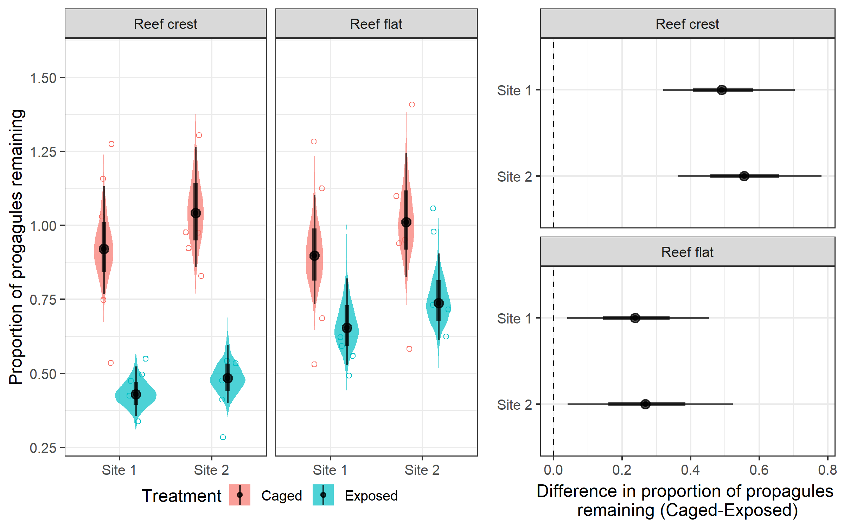

Figure 1

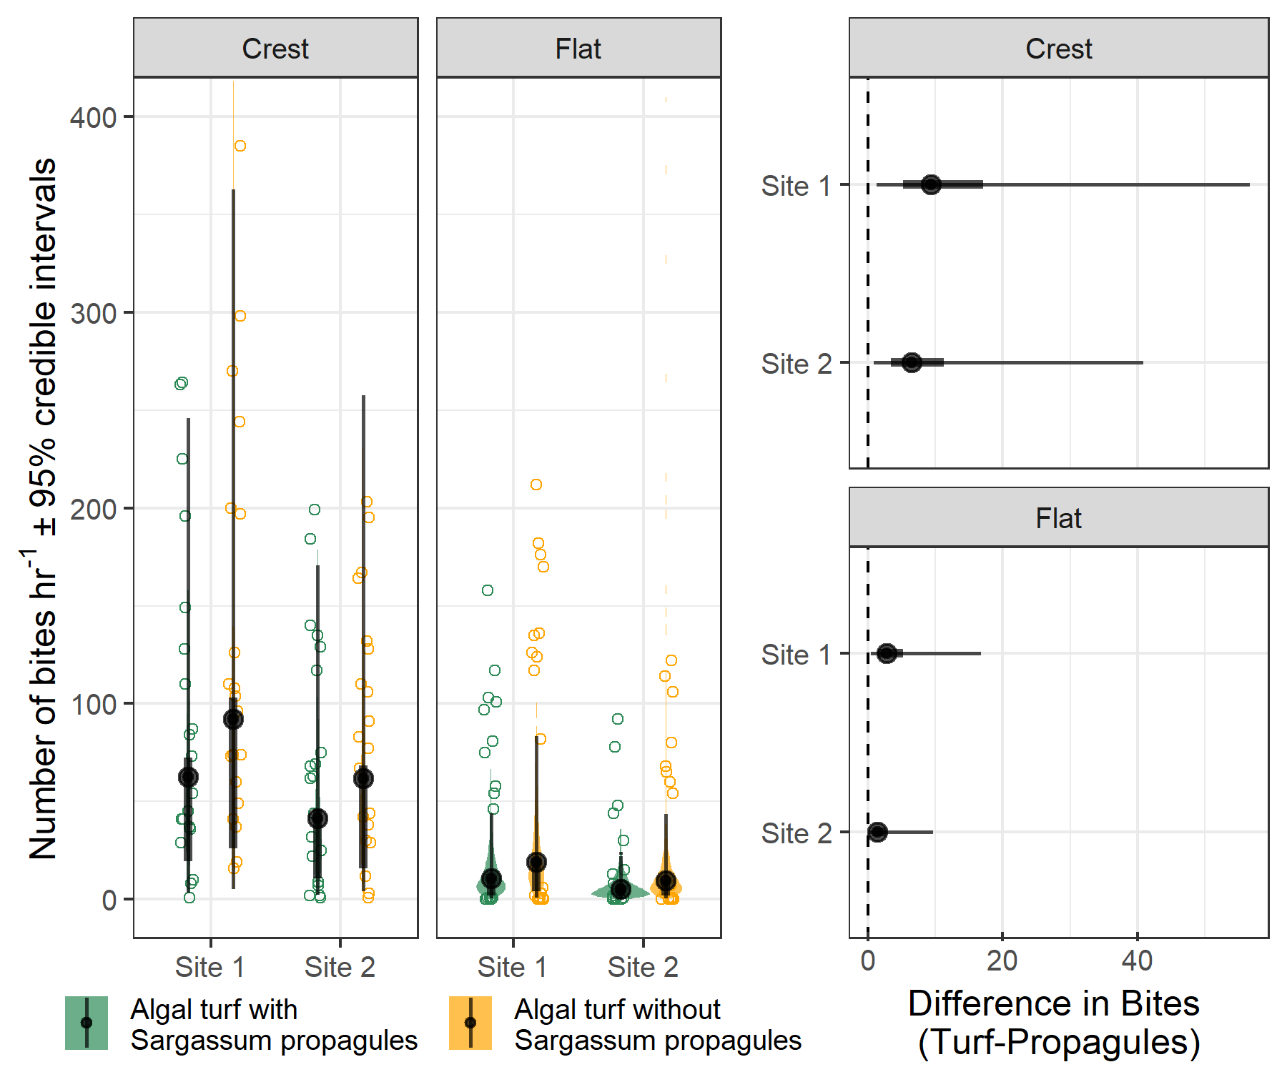

Figure 2

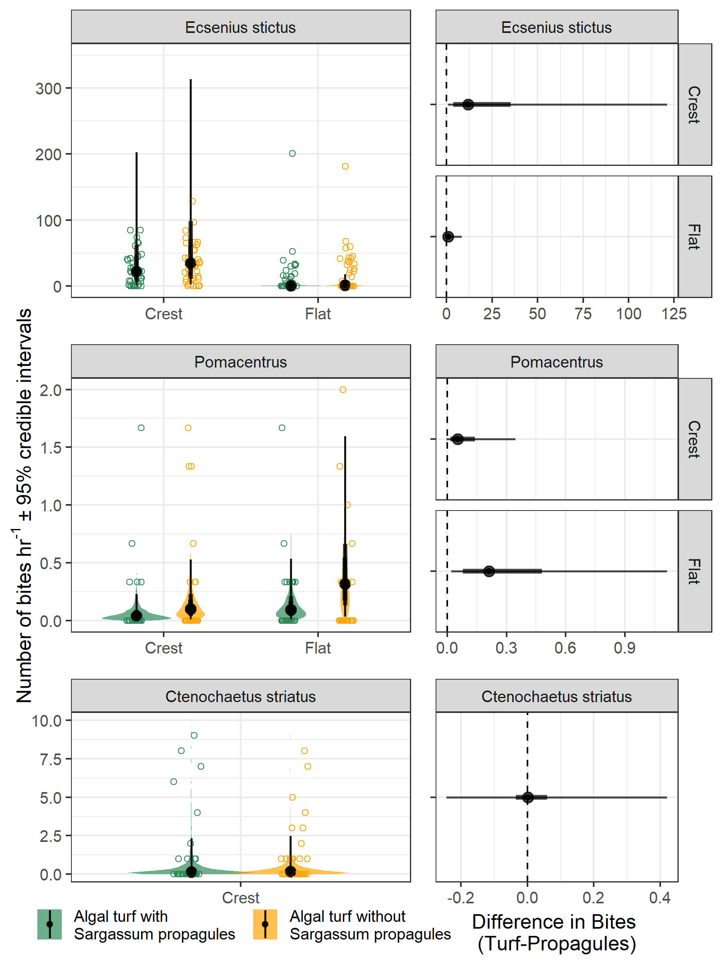

Figure 3

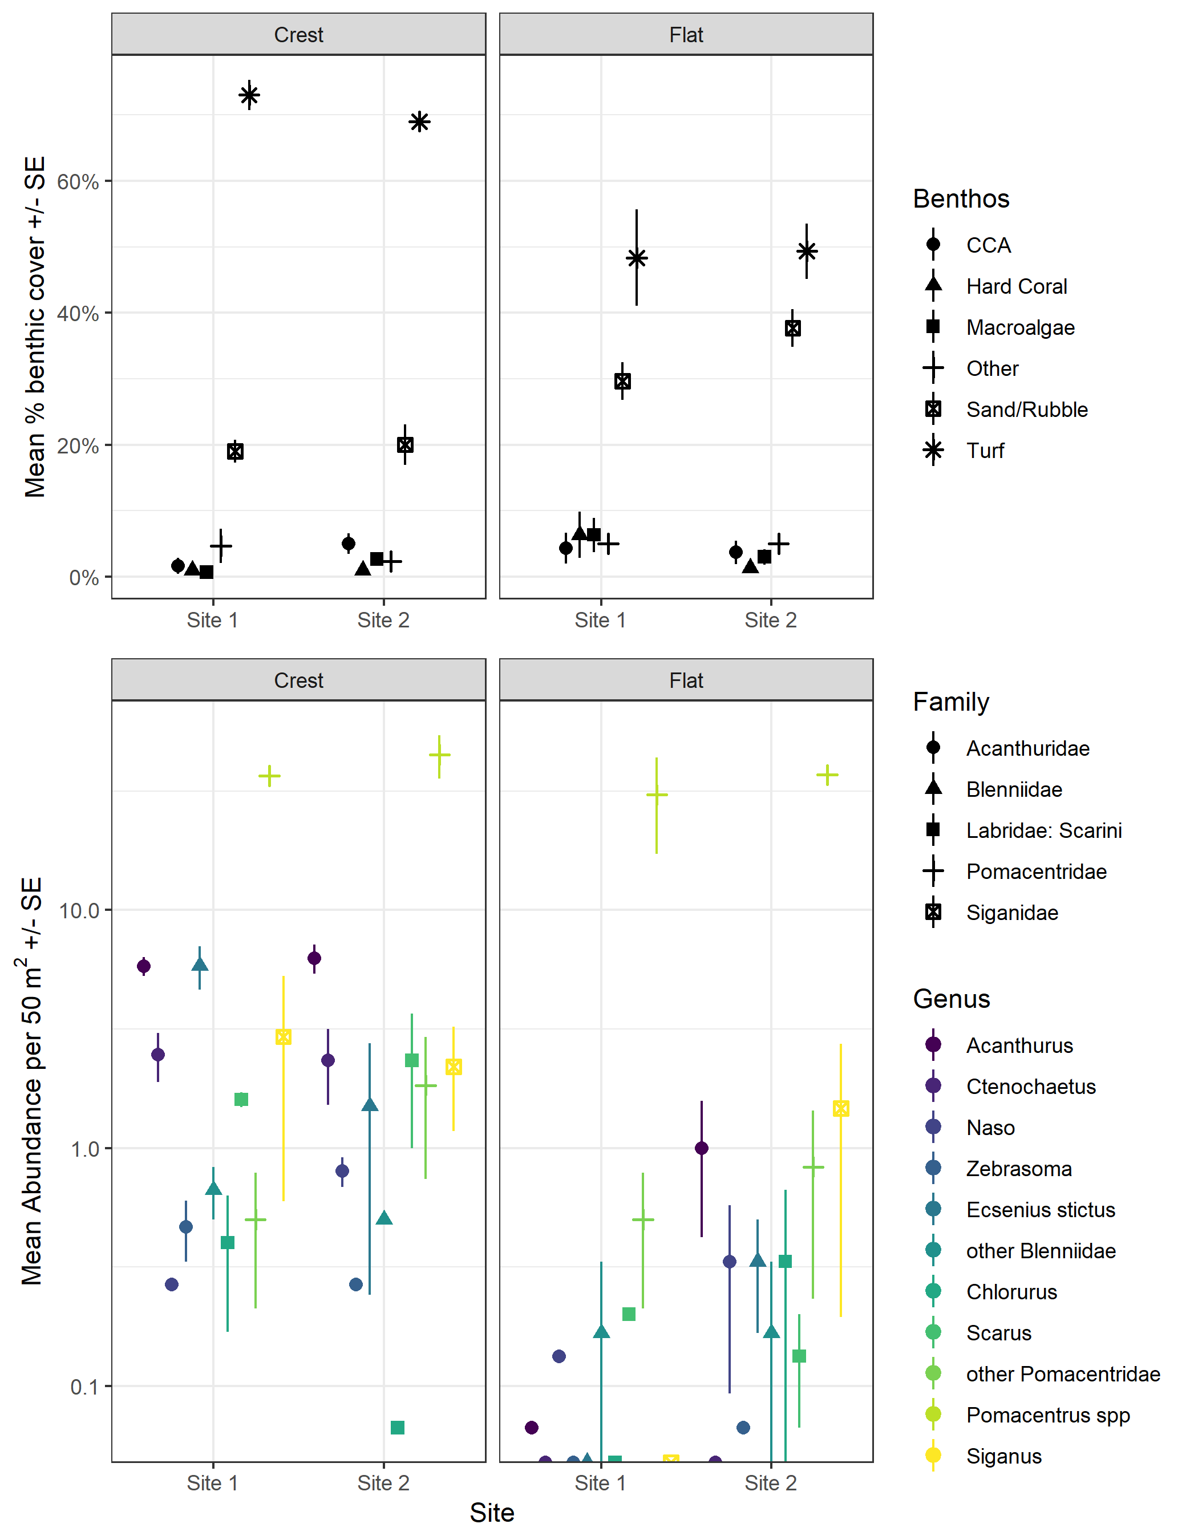

Figure 4